《Theory of Elasticity》
课程负责人：糜长稳
主讲人：糜长稳，章公也，吴佰建
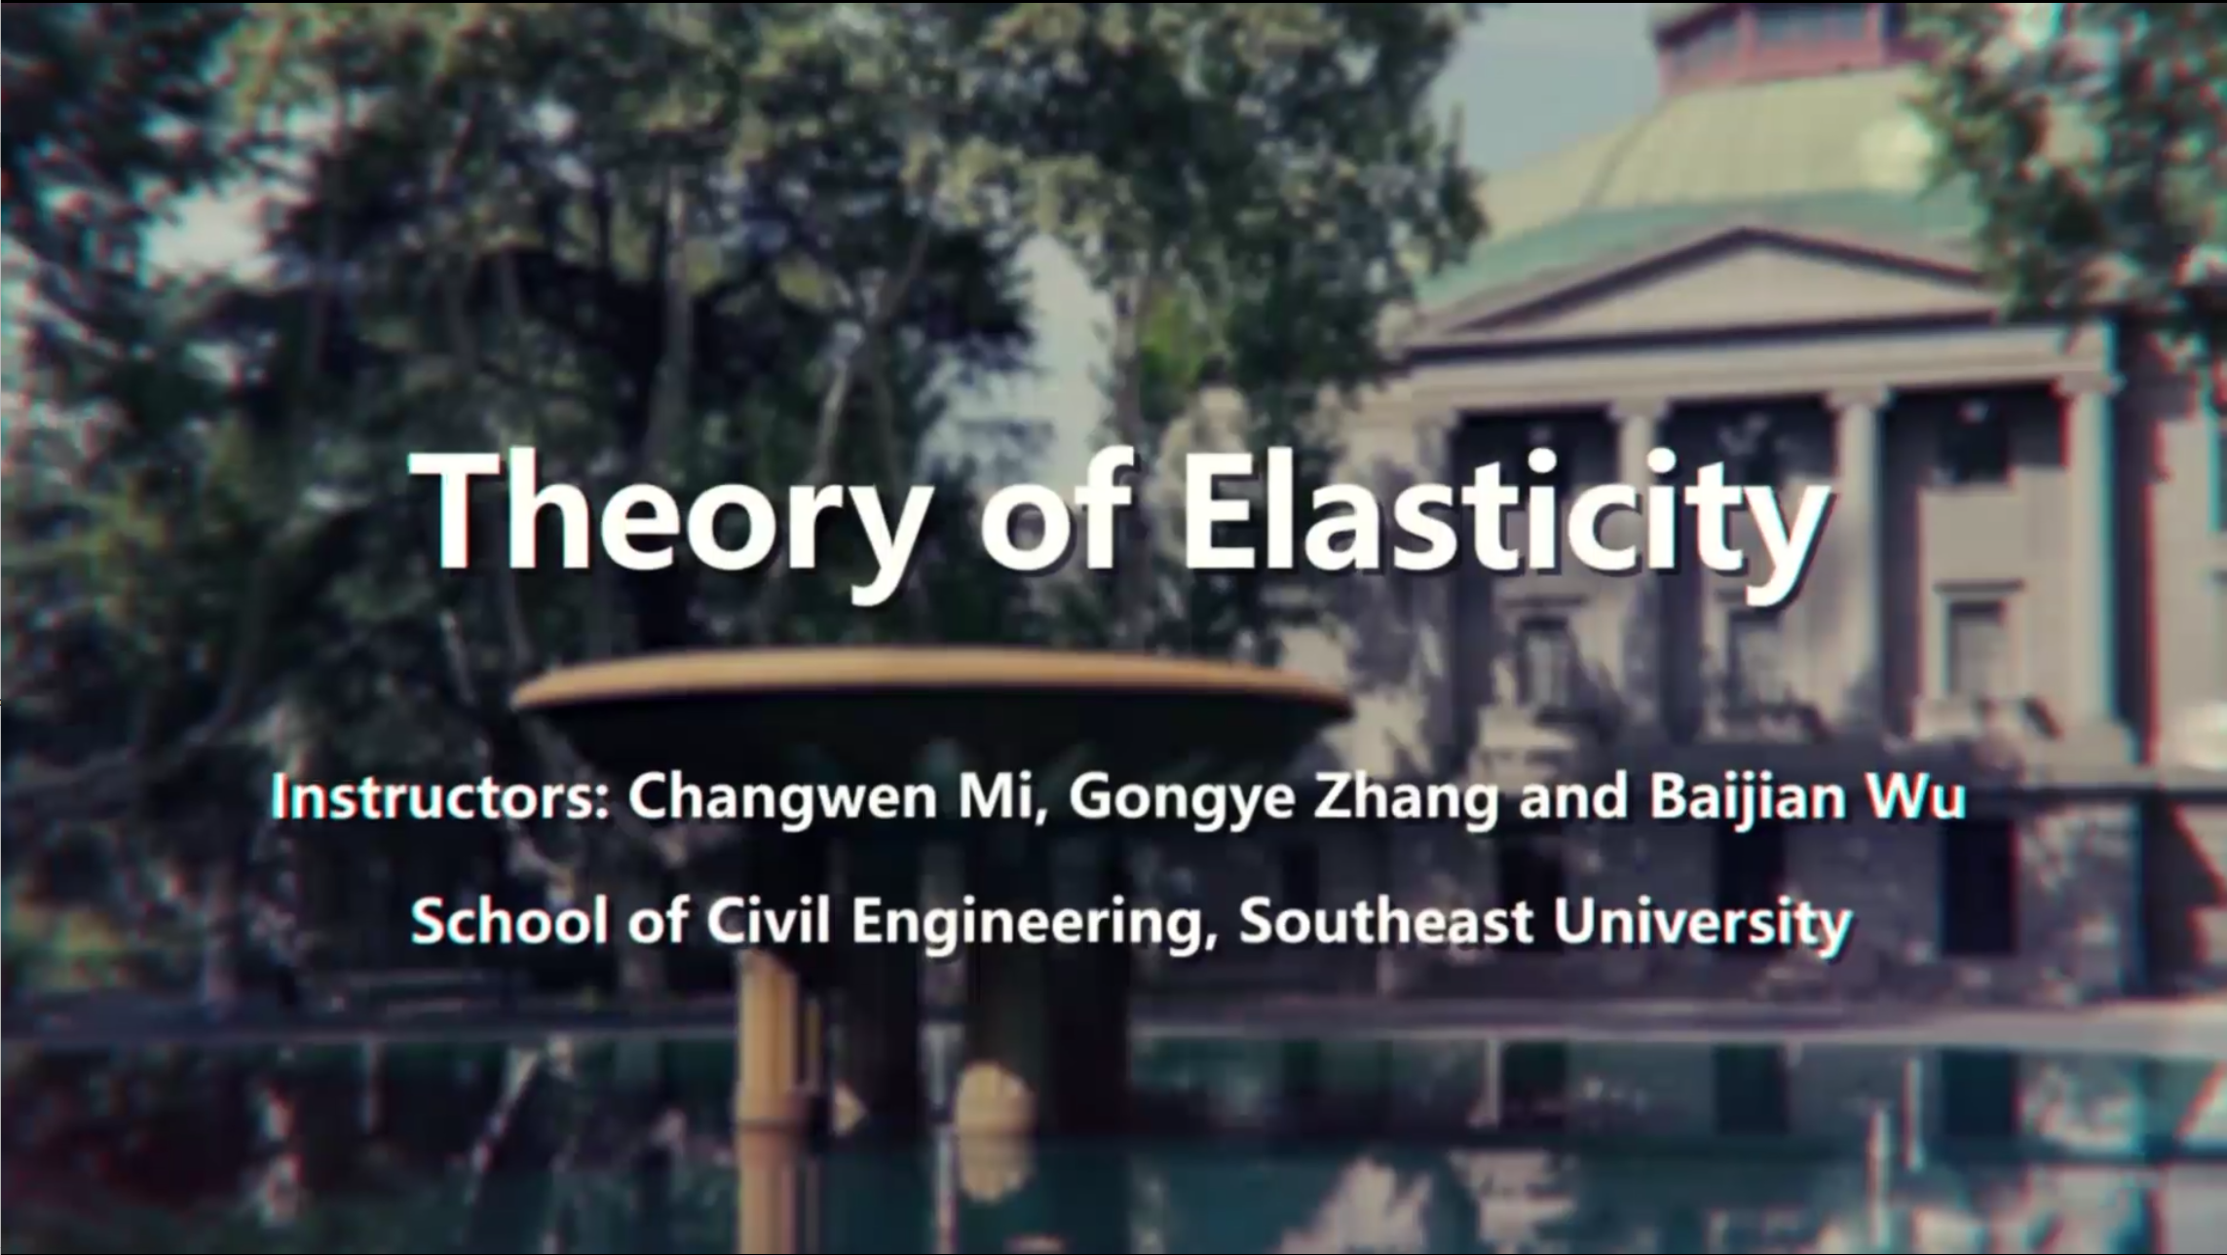
课程认定：教育部爱课程在线教学国际平台
课程简介：In this course, we will help you to get familiar with the major contents of elasticity theory. As you may already know, elasticity is one of the most important courses in many engineering subjects such as mechanics, civil engineering, mechanical engineering, transportation engineering and materials science and engineering. This course will require some reasonable background knowledge in advanced mathematics, linear algebra, statics and mechanics of materials. The major contents of this course involve the fundamentals of tensor, three and two-dimensional theory of elasticity, governing equations, boundary conditions, typical solution strategy and solution method, as well as many illustrating examples. This course particularly emphasizes on the integration of mathematical knowledge and mechanical principles. Throughout the process, we will go through the origin, development and maturation of the basic equations of elasticity, such that you can get a deep understanding about the logic flow of this theory. If you wish to lay a solid mathematical foundation for the further learning of mechanics courses, taking this course is a wise choice. Upon completion of this course, your abilities of calculating, analyzing and self-learning mechanical knowledge will be enhanced. You will also able to propose some new mechanical models and make some routine analysis by yourself. This course will also prepare you better for more advanced courses in mechanics and engineering, both in terms of theory and engineering practice.
Upon the completion of this course, students are expected to: (1) understand the assumptions, research objects and major topics of elasticity theory; (2) familiarize with the governing equations, boundary conditions, formulations and conventional analytical solution methods; (3) know how to solve simple two and three-dimensional elastic problems. Through these rigorous trainings, students’ capabilities on analyzing, calculating and self-learning mechanics problems can be significantly solidified. As a result, students should be more prepared for mechanics courses at a more advanced level and more capable of conducting research activities on solid mechanics.
课程链接：
https://www.icourse163.org/course/SEU1-1458200165


