附件1 【中英文全文投稿模板】

预应力装配式节点抗震性能研究
（二黑，居中）

王□□¹，刘□□² 4号仿体，居中
(1.东南大学 土木工程学院，江苏 南京 210096；2. 研究院，上海 200092)
摘要包含：目的，方法，结果，结论（300字左右）
摘 要：为了推广装配式结构在强震区的应用，本文提出了一种新型预应力装配式节点，□□□□□。
关键词：预制混凝土；抗震；强震区；□□□□□ （5个左右关键词）
中图分类号：TU4 (必填） 文献标志码：A

4号Times New Roman加粗，首词首字母大写，其余小写，应与中文题名一致。

Experimental investigation of a precast connection
WANG Chunlin¹ , LIU Ye²
5号Times New Roman居中，姓氏字母大写，名字首字母大写，其余小写。
(Southeast University, Jiangsu 210096 China)
6号, 单位，邮编中英文一致
Abstract: To develop a precast concrete frame suitable for high seismic zones, a new precast concrete beam-columnconnection with additional all-steel bamboo-shaped energy dissipater was proposed in this paper.

Key words: precast; concrete; beam-column connection; energy dissipater (5个左右关键词)

引言
正文内容5号宋体□□□□□□□□□□□□□□□□□□□□□□□□□□□□□□□□□□□□□□□□□□□□□□□□□□□□□□□□□□□□□□□□□□□□□□□□□□□□□□□□□□□。

1 试验研究 3号黑体，上、下各空半行
1.1 试验模型
正文内容5号宋体□□□□□□□□□□□□□□□□□□□□□□□□□□□□□□□□□□□□□□□□□□□□□□□□□□□□□□□□□□□□□□□□□□□□□□□□□□□□□□□□□□□,见表1。（图随文走，所有图表紧跟在文字说明后面，且务必保证图、表、公式序号连续，参考文献在文字中要标有出处。）

表1 相关系数小于2/3的组合情形表
Table 1 Combination situation for correlation coefficients less than 2/3 mm
相关系数 | □□□ | □□□ | □□□ | □□□ | □□□ | □□□
洪水历时 | 23 | 25 |  |  | 31 | 28
□□□□ | 14 | 41 | 140 | 180 | 83 | 100
（尽量采用三线表，图表需清晰，注意图表单位的标注格式）

表2 边跨隔震支座应力
Table 2 Rubber bearing stress of edge span
边跨支座编号 | 最大拉应力（MPa） | 最大压应力（MPa）
1 | 0.752 | -14.568
3 | 0.679 | -14.610
4 | 0.614 | -12.392
6 | 0.520 | -12.501
7 | -2.342 | -6.648
8 | 0.752 | -14.567

横纵坐标标目写清楚
图1楼盖加速度时程实测值
Fig.1 Tine-history curve of acceleration by test (图题小5号)

尽量采用不同线型区分，减少颜色区分，尽量黑白图。

注意单位的标注方式，需采用国际单位。

注意：公式的外文符号应注意正斜体及黑白体，一般变量应斜体，矢量、张量及矩阵应为黑斜体，常量e、π、三角函数、虚数单位i、j、转置T等等应为正体。上下脚标符号如为标识性的，应为正体；如为量的符号，则为斜体。

参考文献：
[1] 黄波, 陈泉, 李涛，等. 国标Q235钢屈曲约束支撑低周疲劳试验研究[J]. 土木工程学报, 2013, 46(6): 29-34.
[2] GB50011-2010建筑抗震设计规范 [S]．北京：中国建筑工业出版社, 2010.
[3] 屠其璞, 王俊德, 丁裕国,等. 气象应用概率统计学[M]. 北京: 气象出版社, 1984:44-46.
[4] 国家林业局. 2010年中国林业发展报告[EB/OL]. (2011-03-01)[2012-06-10]. http://www.forestry.gov.cn/portal/main/s/62/
content-464039.html
[5] Vickery P J, Wadhera D, Powell M D. A hurricane boundary layer and wind field model for use in engineering pplications [J]. Journal of Applied Meteorology and Climatology, 2009, 48(2): 381-405.
[6] 莫庸.台湾9.21大地震多层框架结构震害特点和经验[C]//甘肃省土木建筑学会五十周年学术会议.兰州：中国建筑学会，2003，227-235.

参考文献缺项，请按标准方式著录。各类文献标准著录方式如下：
期刊：[序号]作者. 文献题名[J]. 刊名，年份，卷（期）：起止页码.
专著：[序号]作者. 书名[M]. 出版地：出版者，出版年：起止页码.
论文集：[序号]作者. 文献题名[C]//论文集编者. 论文集名. 出版地：出版者，出版年：所引文章起止页码.
学位论文：[序号]作者. 文献题名[D]. 授予单位所在城市：授予单位，授予时间.
科技报告：[序号]主要责任者. 题名[R]. 出版地：出版者，出版年.
国家标准：[序号]主要责任者. 题名[S]. 出版地：出版者，出版年.
专利文献：[序号]专利申请者或所有者. 专利题名：专利国别，专利号[P]. 公告日期或公开日期[引用日期]. 获取和访问路径
电子文献：[序号]主要责任者. 题名. [文献类型标志/文献载体标志OL]. 出版地：出版者，出版年（更新或修改日期）[引用日期]. 获取和访问路径.
报纸类： [序号]作者.篇名[N].报纸名，出版日期（版次）.
参考文献超过三个作者以上，取其前三个作者并加“,等”字。
外文文献著录规则同上。外国人名，姓前名后，名用缩写，不加缩写点。
中文参考文献需有相应的英文对照。请补充英文翻译，书名、期刊名务必核查准确，英文参考文献保持原样。
请严格按照标准补齐缺项。

Sample Paper Of The East Asia-Pacific Conference on Structural Engineering and Construction
K. K. LI¹, K. S. JOHNSON², and A. T. CHEUNG³
¹School of Civil Engineering, Southeast University, China
² School of Civil Engineering, Tongji University, China
³ School of Civil Engineering, Tsinghua University, China
ABSTRACT
Prepare an informative abstract based on the complete paper. The abstract should provide a concise synthesis of the entire paper, including the purpose of the study, method, main findings, and interpretation of their significance. The abstract should not contain any equations, symbols and references. Furthermore, the abstract should be a self-contained statement that summarizes the entire paper.
Keywords: Style, format, checklist, Microsoft Word.

INTRODUCTION
The recommended length of conference papers is about 18 pages, and the maximum length is 25 pages (maximum) including references, figures, and tables. The maximum file size for the electronic version (Microsoft word file) of the paper is 10 Mbytes. The number of pages is counted using papers with ISO A4 size with 2.5 cm top and bottom margins and 2.0 cm left and right margins.
To submit a conference paper, authors should try their best to typeset their paper following the style given in this template. All papers must be submitted electronically in Microsoft Word format through the conference mail (precastconc@163.com).

GENERAL PAPER STYLE
Authors must use Times New Roman font throughout the paper with single line spacing and 6 pt above and below each paragraph. All text, except for the title, is in 12 pt. Authors can use the Normal style in this template for the text part of the conference paper.

Title
The paper title must be in BOLD 14 PT UPPERCASE. Leave 24 pt between the top margin and the paper title, and leave 12 pt between the paper title and the names of authors. The line spacing of the paper title is exactly 18 pt. Authors can use the Title style in this template.

Authors
The authors’ name is in single line spacing with 12 pt above and below. Authors can use the author style in this template. Please indicate the corresponding author and the presenter together with their email address at the footnote.

Affiliations
Try to fit the affiliation of an author in one line. Don’t leave any blank line between affiliations. The affiliation should be italic. Authors can use the affiliation style in this template.

Abstract
No section number is assigned to the abstract heading, which is in single line spacing with 12 pt above and 6 pt below. Authors can use the heading without number style in this template for the heading of the abstract.

Keywords
Select up to five keywords, which describe the contents of your paper. Leave 6 pt above and below the Keywords.

SECTION (MAJOR HEADING)
Authors can use the Heading 1 style in template for major headings. Major headings should be placed flush with the left margin, typed in BOLD CAPITALS and identified in Arabic numerals. Leave 12 pt and 6 pt above and below major headings, respectively.

Sub-section (Sub-heading)
Authors can use the Heading 2 style for the sub-headings. Sub-headings should be typed in bold upper and lower cases flush with the left margin with a second level of Arabic numerals. Leave 12 pt and 6 pt above and below the sub-headings, respectively.

Sub-sub-section (Sub-sub-heading)
Authors can use the Heading 3 style for the sub-sub-heading. Like the sub-headings, the sub-sub-headings should be typed in bold upper and lower case flush with the left margin, but should be identified with a third level of Arabic numerals. Leave 12 pt and 6 pt above and below sub-sub-headings, respectively. Try to avoid using sub-sub-sub or higher subsections.

EQUATIONS
Including symbols and equations in the text, the variable name and style must be consistent with those in the equations. In equation (1), I used the symbols φ, c and t. In equation (2), ρ and ω are employed. Equations should be indented at the left margin and numbered at the right margin. Leave 6 pt above and below a equation. For examples
(1)
Consider also the following equation
(2)
Equations (1) and (2) are examples to show the required style of equations. Define all symbols the first time they are used. The equation style in this template can be used.

TABLES
Table 1 shows a typical example of a table. Authors should us 10pt Times New Roman font in tables with line spacing equals to 12pt. A caption must be given above the corresponding table. Tables should be centered and put at appropriate places in the paper. The table style can be adopted.
Table 1: An example of table style
Case | x | y | B | J_{min}
I | 4 | 1.0 | (1.0, 0.0) | 0.000201
 | 4 | 1.0 | (0.0, 1.0) | 0.000357
 | 4 | 5.0 | (1.0, 0.0) | 0.001309
 | 4 | 5.0 | (0.0, 1.0) | 0.007228
II | 16 | 1.0 | (1.0, 0.0) | 0.003555
 | 16 | 1.0 | (0.0, 1.0) | 0.002169
 | 16 | 5.0 | (1.0, 0.0) | 0.009673
 | 16 | 5.0 | (0.0, 1.0) | 0.007291
The caption of a table must be centered and typed in bold. The Caption style in the template can be used.

FIGURES
Please refer to Figure 1 for a typical example of a figure. A caption must be given below the corresponding figure. Figures should be centered and put at appropriate places in the paper. Leave 6 pt above and below the figure. The figure style can be used.
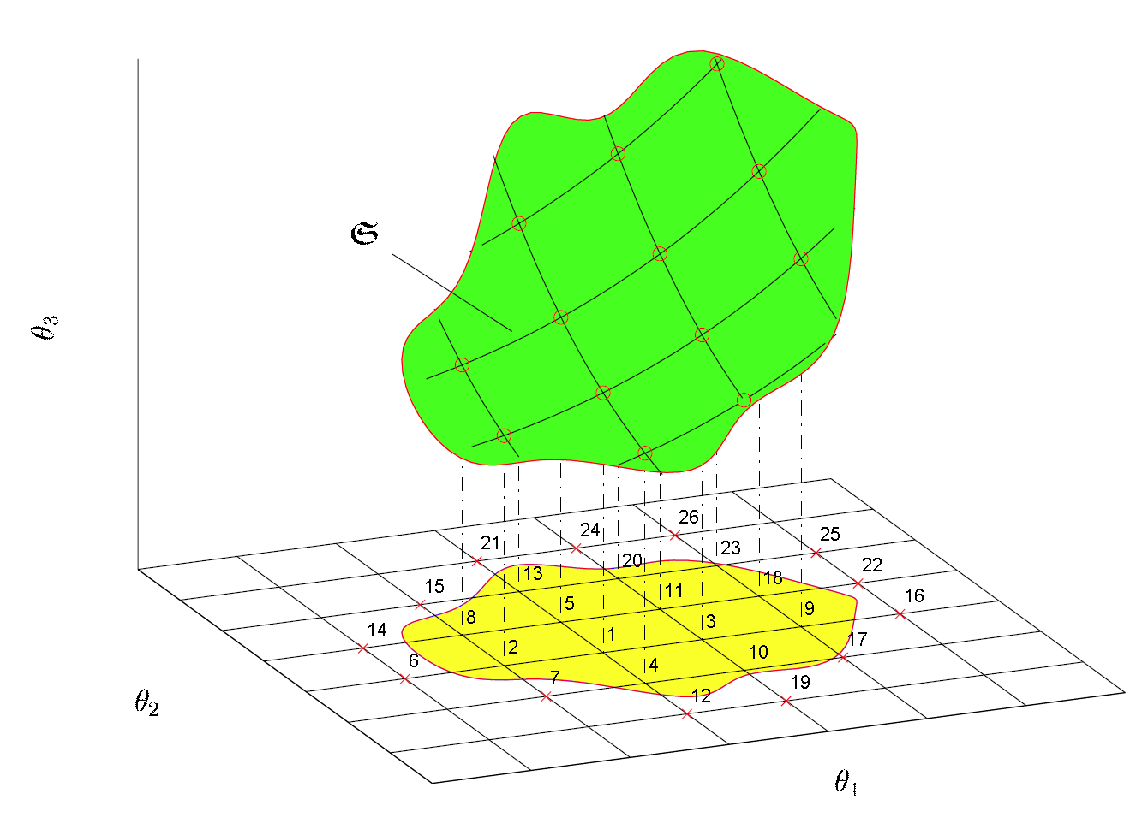
Figure 1: An example of figure style.
The figure caption must be centered and typed in bold. The Caption style in this template can be used.

CITATIONS AND REFERENCES
References should be cited in the text using the “author’s surname year” format in parenthesis. For reference with only one author, it can be cited as (Beck 1989). In case of two authors, the citation should be (Lee and Ng 1998). If there are more than two authors, state the first author only and add “et al.” in the citation as (Kinsler et al. 2000). To cite several references together, semicolon should be used between references as (Beck 1989; Kinsler et al. 2000; Lam 1999; Lee and Ng 1998; Lam et al. 1998; Lam 1997). The references should be cited in tables or figures and legends in the same manner as in the text.
References should be listed in alphabetical order in the list of references without any index number. References should be started with the last name of the first author and followed by the initial. If there are two authors, put “and” between two author names. If there are more than two authors, use comma to separate author names and put “, and” before the last author name. Please refer to the REFERENCES for the sample format of references. Reference (Lee and Ng 1998) is a journal paper, reference (Beck 1989) is a conference paper, reference (Kinsler et al. 2000) is a book, reference (Lam 1997) is a technical report, and reference (Lam 1999) is a PhD thesis. The references should be typed with font size 10 pt, line spacing 12 pt and 1 cm hanging indentation.

CONCLUSIONS
Do not simply repeat the results or discussions, but provide some overall comments on the findings and their applicability in other settings or applications. The discussion of implications should tell the reader what the importance of the work is for others.

ACKNOWLEDGMENTS
A short section may acknowledge assistance and sources of financial support.
REFERENCES
Beck JL (1989). Statistical system identification of structures. Proceedings Fifth International Conference on Structural Safety and Reliability (ICOSSAR’89), New York, pp. 1395–1402.
Kinsler LE, Frey AR, Coppens AB, and Sander JV (2000). Fundamentals of Acoustics. John Wiley & Sons, Inc. Fourth Edition.
Lam HF (1997). Damage detection based on vibration data: A literature review. Technical Report 97-01, Department of Building and Construction, City University of Hong Kong, Tat Chee Avenue, Kowloon, Hong Kong SAR.
Lam HF (1999). Structural model updating and health monitoring in the presence of modeling uncertainties. Ph. D. thesis, Department of Civil Engineering, Hong Kong University of Science and Technology.
Lam HF, Ko JM, and Wong CW (1998). Localization of damaged structural connections based on experimental modal and sensitivity analysis. Journal of Sound and Vibration. 210(1), pp. 91-115.
Lee YY and Ng CF (1998). Sound insertion loss of stiffened enclosure plates using the finite element method and the classical approach. Journal of Sound and Vibration. 217(2). pp. 239-260.

Corresponding author: Email: kkli@seu.edu.cn
Presenter: Email: jks@tongji.edu.cn

